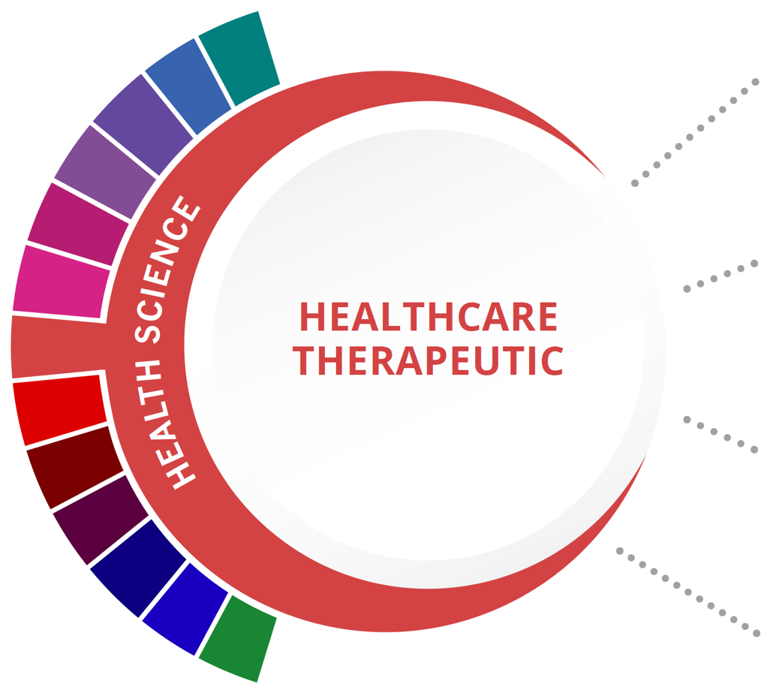
Statewide Program of Study: Healthcare Therapeutic; Health Science Career Cluster
Level 1 | Principles of Health Science
Level 2 | Medical Terminology
Level 3 | Anatomy and Physiology
Level 4 | Health Science Theory/  Health Science Clinical

This Program of Study will also earn the student a Public Service for high school graduation.

HIGH SCHOOL/ INDUSTRY CERTIFICATION | CERTIFICATE/ LICENSE* | ASSOCIATE’S DEGREE | BACHELOR’S DEGREE | MASTER’S/ DOCTORAL PROFESSIONAL DEGREE
Registered Dental Assistant | Dental Assistant | Dental Hygienist | Dental Hygienist | Dentist
Certified Patient Care Technician | Surgical Technologist | Medical/ Clinical Assistant |  | Physician Assistant
OHS: Certified Nurse Aide/Assistant | Medical Assistant |  |  | Family and General Practitioners
Pharmacy Technician | Pharmacy Aides |  |  | Pharmacist
Additional industry-based certification information is available on the TEA CTE website. For more information on postsecondary options for this program of study, visit TXCTE.org.
Occupations | Median Wage | Annual Openings | % Growth
Medical Assistants | $29,598 | 8,862 | 30%
Surgical Technologists | $45,032 | 1,150 | 20%
Dental Hygienists | $73,507 | 1,353 | 38%
Physicians and Surgeons | $213,071 | 1,151 | 30%
Dental Assistants | $34,840 | 4,422 | 31%

WORK BASED LEARNING AND EXPANDED
LEARNING OPPORTUNITIES
Exploration Activities: | Work Based Learning  Activities:
SkillsUSA  Health Occupation Students of America  (HOSA) | Volunteer at a community wellness center, hospital, assisted living, or nursing home.

The Healthcare Therapeutic program of study introduces students to occupations and educational opportunities related to diagnosing and treating acute, episodic, or chronic illness independently or as part of a healthcare team. This program of study also includes an introduction to the opportunities associated with providing treatment and counsel to patients as well as rehabilitative programs that help build or restore daily living skills to persons with disabilities or developmental delays.
The Health Science Career Cluster focuses on planning, managing, and providing therapeutic services, diagnostics services, health informatics, support services, and biotechnology research and development. To pursue a career in the health science industry, students should learn to reason, think critically, make decisions, solve problems, communicate effectively, and work well with others.

Successful completion of the Healthcare Therapeutic program of study will fulfill requirements of a Public Service endorsement or STEM endorsement if the math and science requirements are met. Revised - July 2020

O'DONNELL HS COURSE INFORMATION

COURSE  NAME | SERVICE ID | PREREQUISITES (PREQ)  COREQUISITES (CREQ) | Grade
Principles of Health Science | 13020200 (1 credit)  Course #: 7100 | None | 9-10
Medical Terminology | 13020300 (1 credit)  Course #: 7303 | None | 9-12
Anatomy and Physiology | 13020600 (1 credit)  Course #: 7304 | PREQ: Biology and a second science credit | 10-12
Health Science Theory/  Health Science Clinical | 13020410 (2 credits)  Course #: 7305 | PREQ: Biology  CREQ: Must be taken together in consecutive block | 10-12
OHS Industry-Based Certification Opportunities |  | OHS Value-Added Certification Opportunities
POS Industry-Based Certification: Certified Nurse Aide/Assistant (CNA) | Offered following Health Science Theory/Clinical | CPR Heart Saver | TBD when offered
Additional Industry-Based Certification not included in POS: OSHA 30 Hour General Industry | TBD when offered
Additional Industry-Based Certification not included in POS: Emergency Medical Technician Basic (EMT) | Available following 18th birthday

FOR ADDITIONAL INFORMATION ON THE HEALTH SCIENCE CAREER CLUSTER, PLEASE CONTACT:
CTE@tea.texas.gov
https://tea.texas.gov/cte

O'Donnell ISD offers career and technical education programs in Business & Industry, Education & Training, Animal Science, Business Management, and Accounting & Financial Services. Admission to these programs is based on student qualifications. It is the policy of O'Donnell ISD not to discriminate on the basis of race, color, national origin, sex or handicap in its vocational programs, services or activities as required by Title VI of the Civil Rights Act of 1964, as amended; Title IX of the Education Amendments of 1972; and Section 504 of the Rehabilitation Act of 1973, as amended. It is the policy of O'Donnell ISD not to discriminate on the basis of race, color, national origin, sex, handicap, or age in its employment practices as required by Title VI of the Civil Rights Act of 1964, as amended; Title IX of the Education Amendments of 1972; the Age Discrimination Act of 1975, as amended; and Section 504 of the Rehabilitation Act of 1973, as amended. O'Donnell ISD will take steps to assure that lack of English language skills will not be a barrier to admission and participation in all educational and vocational programs. For information about your rights or grievance procedures, contact the high school office.

